EC2 – Virtual Server
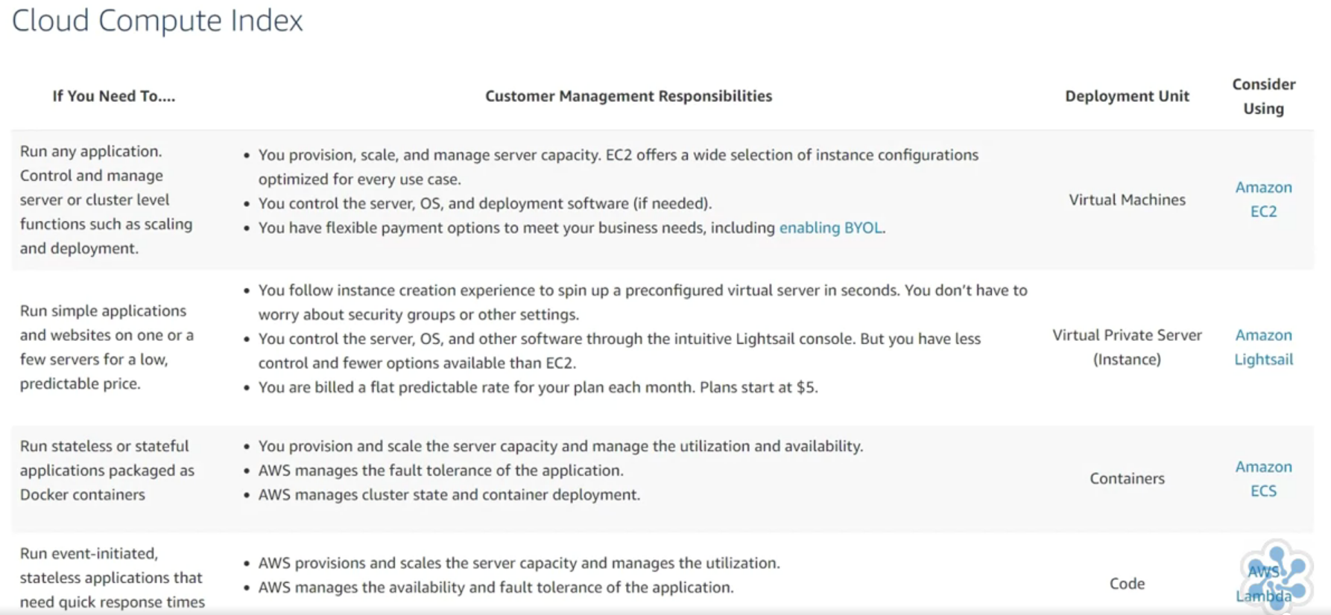

EC2 – Elastic Compute Cloud
AMI – Amazon Machine Instance
Instance Type – Size of instance: ECUs. vCPUs, Phys processor, clock, memory, …

On-Demand Short term / flat rate
Reserved Purchased for set period / cheaper then on-demand – long term predicatable workload
Scheduled Similar to Reserved – but available on a schedule / charged if not used
Spot Bid for unused instances / not guaranteed for fixed period
Capacity Reservation

Tenancy:
Relates to underlying host
Shared May share with other customers
Dedicated Dedicated instances and hosts
Instance: Hardware no other customer can access
Hosts: Additional visibility and control on a physical host

User Data
Perform functions on boot
Download latest OS

Storage Options
Persistent Attach Elastic Block Storage (EBS) – EBS volumes can be detached / attached to different EC2 inst
Ephemeral Created using local storage – as soon as instance is terminated data is lost

Security Group

Select existing key-pair (or create new one)

ELB Elastic Load Balancer
Application ALB Layer 7 (Application)
Network NLB Layer 4 (Transport)
Classic Only use with EC2 Classic (i.e. don’t)

VPC Virtual Private Cloud

AZ Availability Zone

SSL Secure Sockets Layer
TLS Transport Layer Security
X.509 certificate

ACM AWS Certificate Manager

IAM Identity & Access Management

AWS Lambda Serverless compute service
Without having to manage EC2 instances
Charges per 100ms of use – only when code running
Runs on specific triggers e.g. S3 file upload

AWS Management Console
AWS CLI

KMS Key Management Service

ENI Elastic Network Interfaces

DLQ Dead Letter Queue
SNS Simple Notification Service
SQS Simpel Queue Service

ARN Amazon Resource Name

SAM AWS Serverless Application Model

Event Sources:
Poll: Kinesis, SQS, DynamoDB
Push: All remaining supported sources

Lambda monitored using AWS CloudWatch & CloudTrail

PaaS Platform as a Service

EC2 is the most basic service, as it only provides the instance with a base image while you supply the automation, configuration, and code to run. It's the most flexible option, but it also requires the most work from you.

Lambda is the complete opposite in that it handles provisioning, underlying OS updates, monitoring, and failover transparently. You only need to provide the code that will run and specify what events should trigger your code. Scaling a Lambda function happens automatically; AWS provisions more instances as needed and only charges you for the time your function runs.

Elastic Beanstalk is a PaaS that lets you deploy code without worrying about the underlying infrastructure. However, compared to Lambda, it does provide more choices and controls. You can deploy complete applications to Elastic Beanstalk using a more traditional application model compared to deploying individual functions in Lambda.

Amazon Elastic Container Service (Amazon ECS) and Amazon Elastic Container Service for Kubernetes (Amazon EKS) are centered around containers compared to the individual functions of Lambda. ECS and EKS require less managerial overhead compared to running containers on EC2 instances, but generally require some operational expertise. Lambda is ideal for developers who just want to focus on their code.

